SQL PROJECT

**DATABASE NAME:**

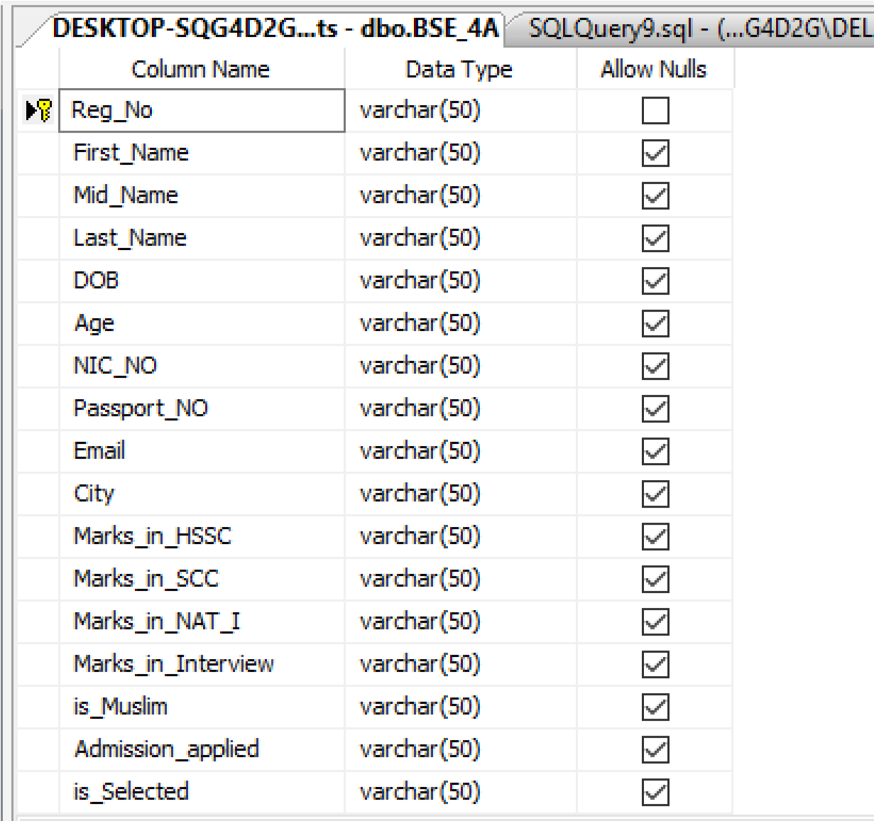

**CREATE**

**TABLE**

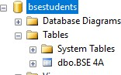

**SET**

**TABLE**

**NAME:**

**ADD PRIMARY KEY:**

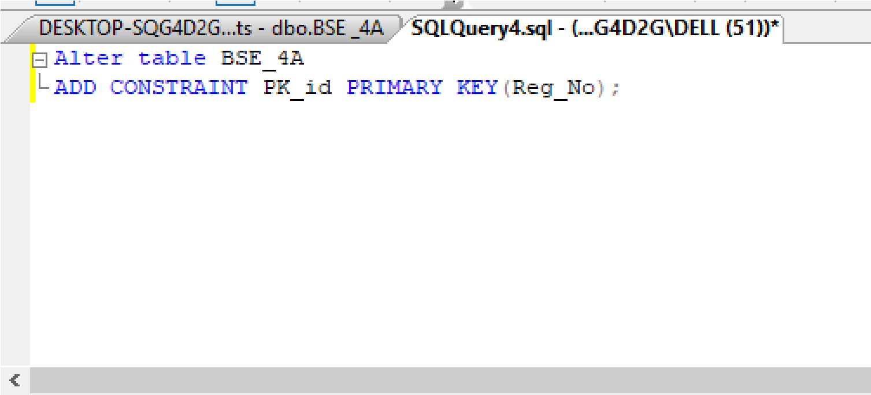

**QUERY TO ADD STUDENT1 DATA:** INSERT INTO BSE_4A

(Reg_No,First_Name,Mid_Name,Last_Name,DOB,Age,NIC_NO,Passport_NO,Email,City,Marks_in_HSSC,Marks_

in_SCC,Marks_in_NAT_I,Marks_in_Interview,is_Muslim,Admission_applied,is_Selected)

VALUES ('2021-BSE-006', 'AYESHA', 'TARIQ', 'SATTI', '8/8/2002',

'20','37405_06218894','A1B1C1D1E1','ayeshasatti550@gmail.com','Rawalpindi',1062,1060,75,100,1,'BSE',1);

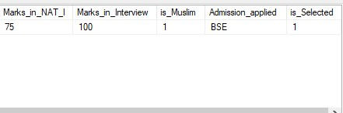

**OUTPUT:**

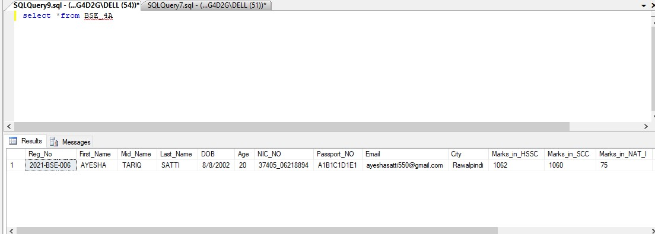

**QUERY TO ADD STUDENT2 DATA:**

INSERT INTO BSE_4A

(Reg_No,First_Name,Mid_Name,Last_Name,DOB,Age,NIC_NO,Passport_NO,Email,City,Marks_in_HSSC,Marks_

in_SCC,Marks_in_NAT_I,Marks_in_Interview,is_Muslim,Admission_applied,is_Selected)

VALUES ('2021-BSE-001', 'EZZA', 'TARIQ', 'SATTI', '23/5/2002',

'22','37405_06258494','A2B2C2D2E2','ezzasatti550@gmail.com','Rawalpindi',1000,987,68,100,1,'BS-URDU',1);

**QUERY TO ADD STUDENT3 DATA:**

**OUTPUT:**

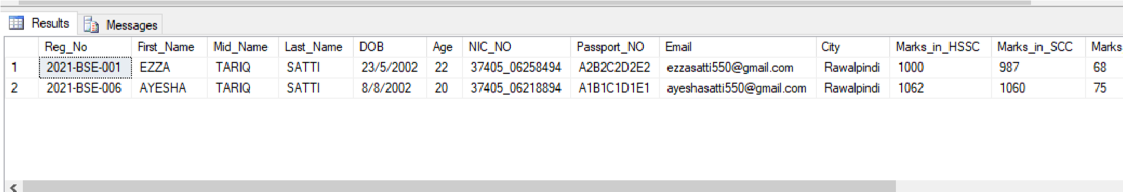

INSERT INTO BSE_4A

(Reg_No,First_Name,Mid_Name,Last_Name,DOB,Age,NIC_NO,Passport_NO,Email,City,Marks_in_HSSC,Marks_

in_SCC,Marks_in_NAT_I,Marks_in_Interview,is_Muslim,Admission_applied,is_Selected)

VALUES ('2021-BSE-002', 'HADI', 'TARIQ', 'SATTI', '27/7/2002',

'15','37485_06258494','A3B3C3D3E3','hadisatti550@gmail.com','Lahore',1002,887,80,99,1,'BSE',1);

**OUTPUT:**

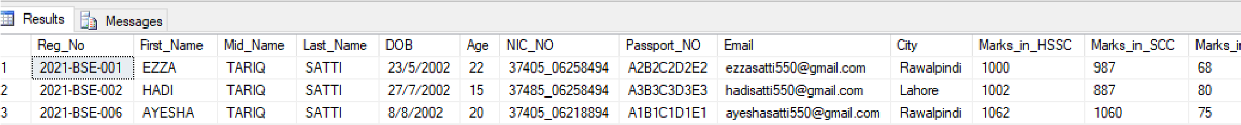

**CONNECTION WITH VISUAL STUDIO:**

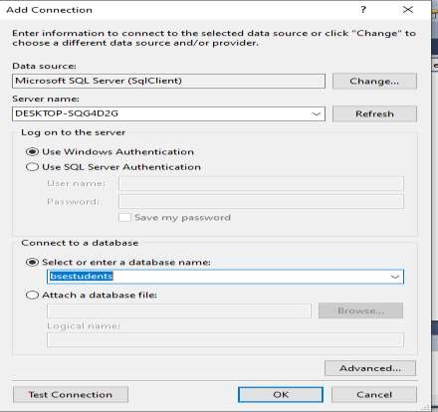

**CODE FOR SHOW,REMOVE AND ADD:**

**SHOW**

private void button3_Click(object sender, EventArgs e)

{

con.Open();

SqlDataAdapter adpt = new SqlDataAdapter("SELECT * FROM BSE_4A", con);

DataTable dt = new DataTable(); adpt.Fill(dt);

dataGridView1.DataSource = dt;

con.Close();

}

**REMOVE**

private void button2_Click(object sender, EventArgs e)

{

con.Open();

string query = "DELETE FROM BSE_4A WHERE Reg_NO='" + textReg_NO.Text + "'";

SqlCommand cmd = new SqlCommand(query, con); cmd.ExecuteNonQuery();

con.Close();

MessageBox.Show("RECORD DELETED!", "Delete Record");

}

**ADD DATA:**

private void button1_Click(object sender, EventArgs e)

{ con.Open();

MessageBox.Show("Connection open"); SqlCommand cm1;

string Reg_No=textReg_NO.Text; string First_Name=textFirst_Name.Text; string Mid_Name=textMid_Name.Text; string Last_Name=textLast_Name.Text; string DOB=textDOB.Text; string Age=textAge.Text;

string NIC_NO=textNIC_NO.Text; string Passport_NO=textPassport_NO.Text;

string Email=textEmail.Text;

string City=textCity.Text;

string Marks_in_HSSC=textMarks_in_HSSC.Text; string Marks_in_SCC=textMarks_in_SCC.Text;

string Marks_in_NAT_I=textMarks_in_NAT_I.Text; string Marks_in_Interview=textMarks_in_Interview.Text;

string is_Muslim=textis_Muslim.Text; string Admission_applied=textAdmission_applied.Text;

string is_Selected = textis_Selected.Text;

string query = "Insert into

BSE_4A(Reg_No,First_Name,Mid_Name,Last_Name,DOB,Age,NIC_NO,Passport_NO,Email,City,Marks_in_HSSC,Marks_i n_SCC,Marks_in_NAT_I,Marks_in_Interview,is_Muslim,Admission_applied,is_Selected) values ('" + Reg_No + "','" + First_Name + "','" + Mid_Name + "','" + Last_Name + "','" + DOB + "','" + Age + "','" + NIC_NO

+ "','" + Passport_NO + "','" + Email + "','" + City + "','" + Marks_in_HSSC + "','" + Marks_in_SCC + "','" + Marks_in_NAT_I + "','" + Marks_in_Interview + "','" + is_Muslim + "','" + Admission_applied +

"','" + is_Selected + "')"; cm1 = new SqlCommand(query, con); cm1.ExecuteNonQuery(); cm1.Dispose(); con.Close();

}

**OUTPUT:**

**FOR REMOVING STUDENT:**

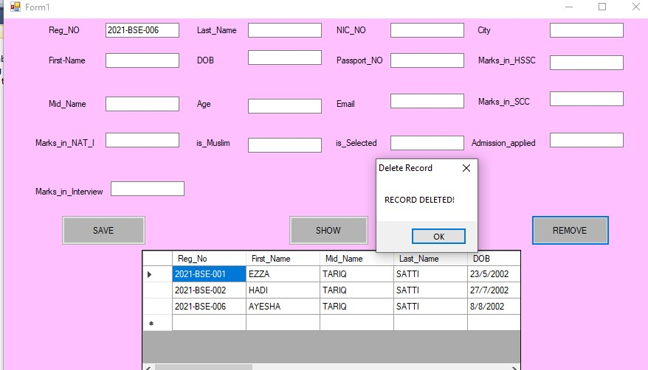

**DATASHOW AFTER REMOVING:**

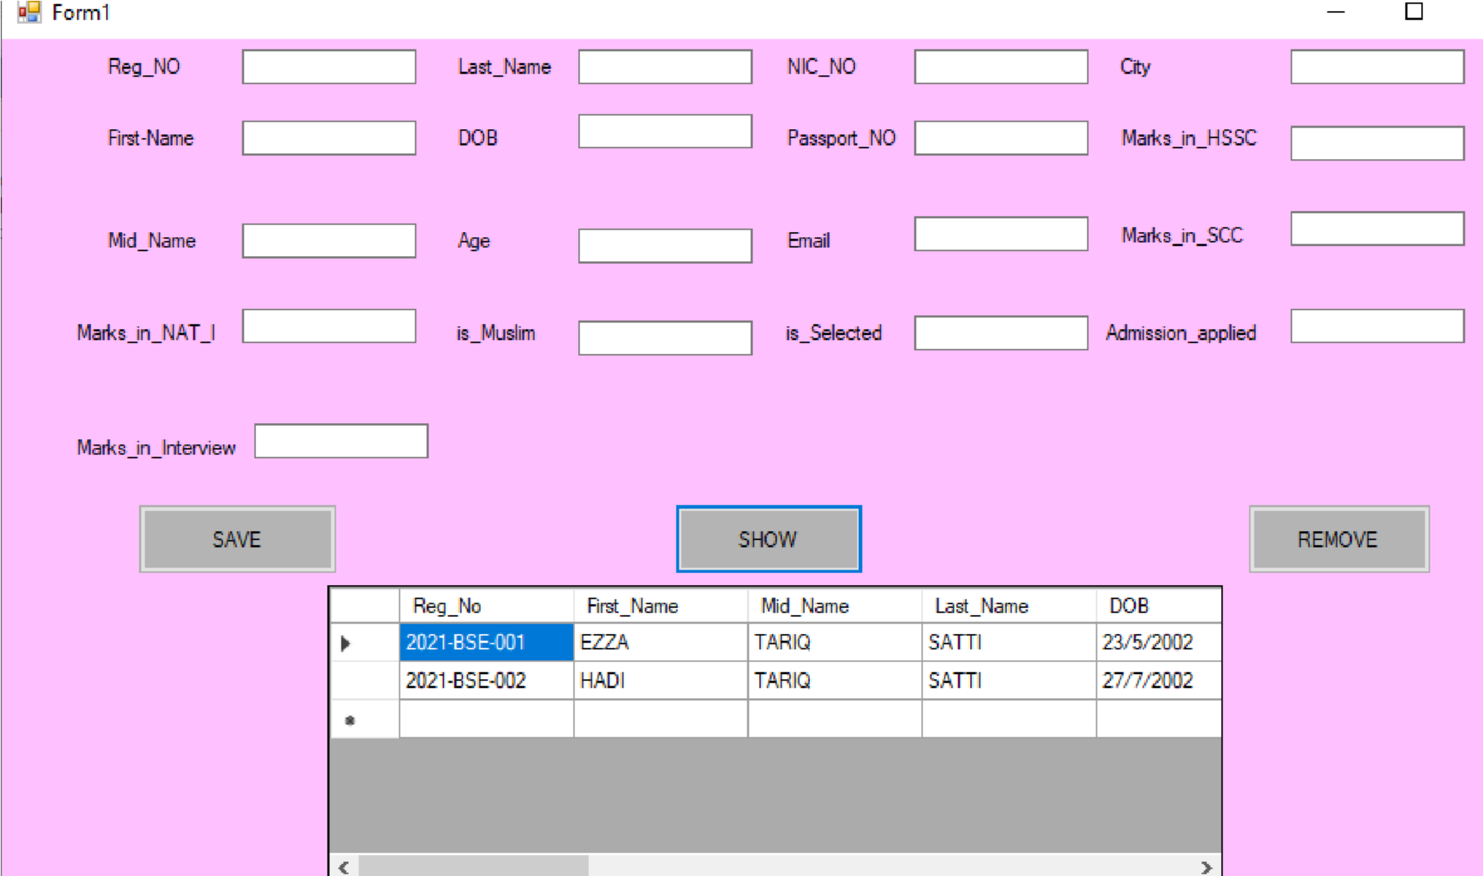

**ADD STUDENT:**

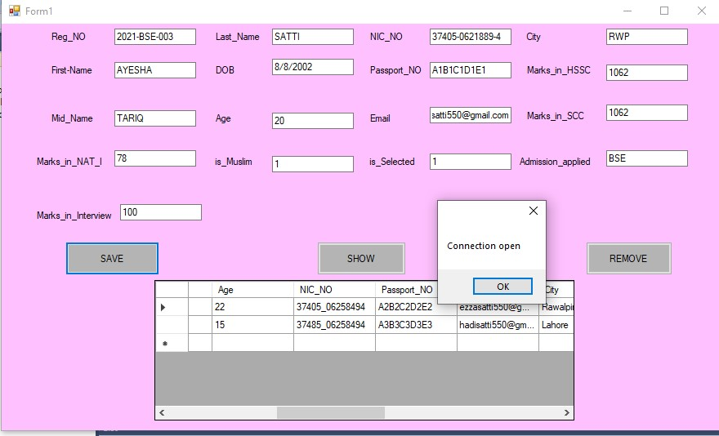

**AFTER ADDING SHOW DATA:**

